Zum Aktivieren der Funktion muss xampp konfiguriert werden.

https://stackoverflow.com/questions/55222973/problem-in-websocket-connection-xampp-and-php

Websocket starten

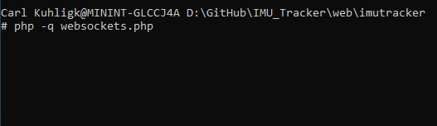

Erklärung zum code

<https://developer.mozilla.org/de/docs/Web/API/WebSockets_API/Writing_WebSocket_servers>

Websocket Client opening request

GET /websockets.php HTTP/1.1

Host: 127.0.0.1:12345

Connection: Upgrade

Pragma: no-cache

Cache-Control: no-cache

User-Agent: Mozilla/5.0 (Windows NT 10.0; Win64; x64) AppleWebKit/537.36 (KHTML, like Gecko) Chrome/91.0.4472.124 Safari/537.36 OPR/77.0.4054.254

Upgrade: websocket

Origin: http://localhost

Sec-WebSocket-Version: 13

Accept-Encoding: gzip, deflate, br

Accept-Language: de-DE,de;q=0.9,en-US;q=0.8,en;q=0.7

Sec-WebSocket-Key: ziQVgMWZIHqrqg4bFxmYxg==

Sec-WebSocket-Extensions: permessage-deflate; client_max_window_bits

Magic String:

"Sec-WebSocket-Accept: " . base64_encode(sha1( $client_key . "258EAFA5-E914-47DA-95CA-C5AB0DC85B11",true))

https://stackoverflow.com/questions/13456017/what-does-258eafa5-e914-47da-95ca-c5ab0dc85b11-means-in-websocket-protocol